Here is the video link that is recorded during the pandemic:

[Lab 5 - Part 1](https://youtu.be/bClhu7VlrfY)

[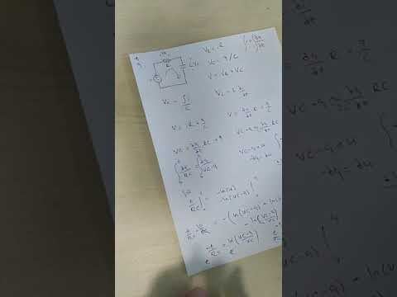](https://youtu.be/bClhu7VlrfY)

[Lab 5 - Part 2](https://youtu.be/bx9AX6shbIg)

[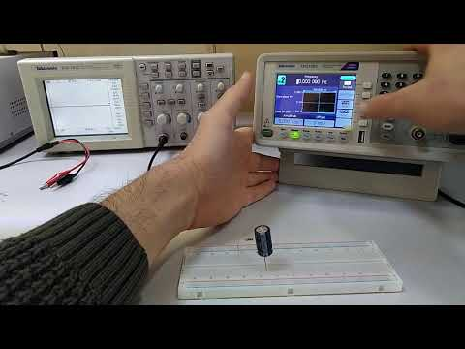](https://youtu.be/bx9AX6shbIg)